logistics_tracking | SBP
V1.0

Revision History
Version | Date | Description | Author
1.0 | 17/02/2026 | Initial Version | Mohammed Megahed

Reviewers
# | Name | Position | Date and Signature
1
2

Acceptance and Signoff
# | Name | Position | Date and Signature
1
2

Contents
1. Introduction 5
1.1. Project Summary 5
1.2. In-Scope 5
1.3. Out-Scope 5
1.4. Target Audience 5
1.5. Abbreviations 5
1.6. Assumptions, Dependencies and Risks 5
1.7. Impact Questionnaire 6
2. Requirements Compliancy Matrix 6
3. Solution Architecture 7
3.1. Solution Description 7
3.2. Non-Functional Requirements 8
3.3. Security Considerations 8
4. Shipment Creation and Dispatch 9
4.1. Sequence Diagram 9
4.2. Flow Description 10
4.3. State Machine Diagram 11
4.4. APIs Contract Agreement 13
4.5. Error Handling 14
5. Real-Time Delivery Tracking 16
5.1. Sequence Diagram 16
5.2. Flow Description 16
5.3. State Machine Diagram 18
5.4. APIs Contract Agreement 20
5.5. Error Handling 21
6. Appendix 24
6.1. Shipment Creation and Dispatch Data Elements 24
6.2. Real-Time Delivery Tracking Data Elements 25
6.3. Solution Architecture Reference Documents 26

1. Introduction

1.1. Project Summary
TrackIt is a real-time shipment tracking and logistics management platform that addresses the need for accurate, end-to-end visibility and efficient coordination of shipments. The system enables users to create shipment orders with pickup and delivery details, calculate shipping rates, generate labels, assign drivers, optimize routes using live traffic data, and track shipments in real time through IoT sensor integration. This improves operational efficiency and enhances customer transparency.

1.2. In-Scope
# | Item
1. | Shipment order creation with pickup and delivery addresses
2. | Shipping rate calculation and label generation
3. | Real-time GPS tracking of shipments
4. | Route optimization with traffic consideration
5. | Driver assignment and task management
6. | Proof of delivery capture (signature, photo)
7. | Delivery notifications to customers

1.3. Out-Scope
# | Item
1. | Warehouse management system
2. | Fleet maintenance scheduling
3. | Cross-border customs clearance
4. | Cold chain temperature monitoring

1.4. Target Audience
# | Stakeholders
1. | Enterprise Architects
2. | Partners and Vendors Technical Leaders
3. | Infrastructure Architects & Engineers
4. | InfoSec Architects & Engineers
5. | Technical Managers
6. | Delivery Leads and Project Managers
7. | Developers

1.5. Abbreviations
# | Abbreviations | Full form
1

1.6. Assumptions, Dependencies and Risks
# | Item | Type | Owner | Comment
1.
2.

2. Requirements Compliancy Matrix
ID. | Title | Description | Compliancy | Comments
FR-1 | TrackIt is a real-time shipment tracking and logistics management platform | TrackIt provides users with real-time visibility into shipment status and logistics activities, enabling efficient tracking and management of deliveries throughout the supply chain. | Compliant
FR-2 | The platform enables shipment creation, GPS tracking, route optimization, and pr | The platform allows users to create shipments, track their location in real time, optimize delivery routes, and confirm proof of delivery to improve operational efficiency and customer satisfaction. | Compliant
FR-3 | Integration with IoT sensors provides accurate real-time location updates | The system provides accurate, real-time location updates by using IoT sensors, enabling users to track assets and personnel efficiently. This supports timely decision-making and improves operational visibility. | Compliant
FR-BR-001 | Shipment Creation | Users can create shipments to enable the tracking and management of goods throughout the delivery process. | Compliant
FR-BR-002 | Rate Calculation | The system calculates rates accurately and consistently to ensure customers are charged the correct amounts according to approved pricing policies. | Compliant
FR-BR-003 | Label Generation | The system generates accurate and compliant labels to ensure products are properly identified and meet regulatory requirements. | Compliant
FR-BR-004 | racking | The organization tracks the real-time location of assets or vehicles to ensure operational visibility, improve security, and support compliance with regulatory requirements. | Compliant
FR-BR-005 | Status Updates | Users receive timely updates on the status of their requests or transactions to ensure transparency and keep them informed throughout the process. | Compliant
FR-BR-006 | Route Optimization | The system ensures that delivery routes are planned to minimize travel time and distance, reducing operational costs and improving delivery efficiency. | Compliant
FR-BR-007 | Driver Assignment | Assign each delivery to a qualified driver to ensure accountability and compliance with operational standards. | Compliant
FR-BR-008 | Proof of Delivery | The organization provides documented confirmation that goods or services have been delivered to the intended recipient. This ensures accountability, supports accurate record-keeping, and enables resolution of delivery disputes. | Compliant
FR-BR-009 | Notifications | Users receive timely notifications about important updates, actions, or changes to ensure they stay informed and can respond as needed. | Compliant
FR-BR-010 | rediction | Provide users with accurate estimated time of arrival (ETA) predictions to support planning and improve customer satisfaction. | Compliant

3. Solution Architecture

3.1. Solution Description
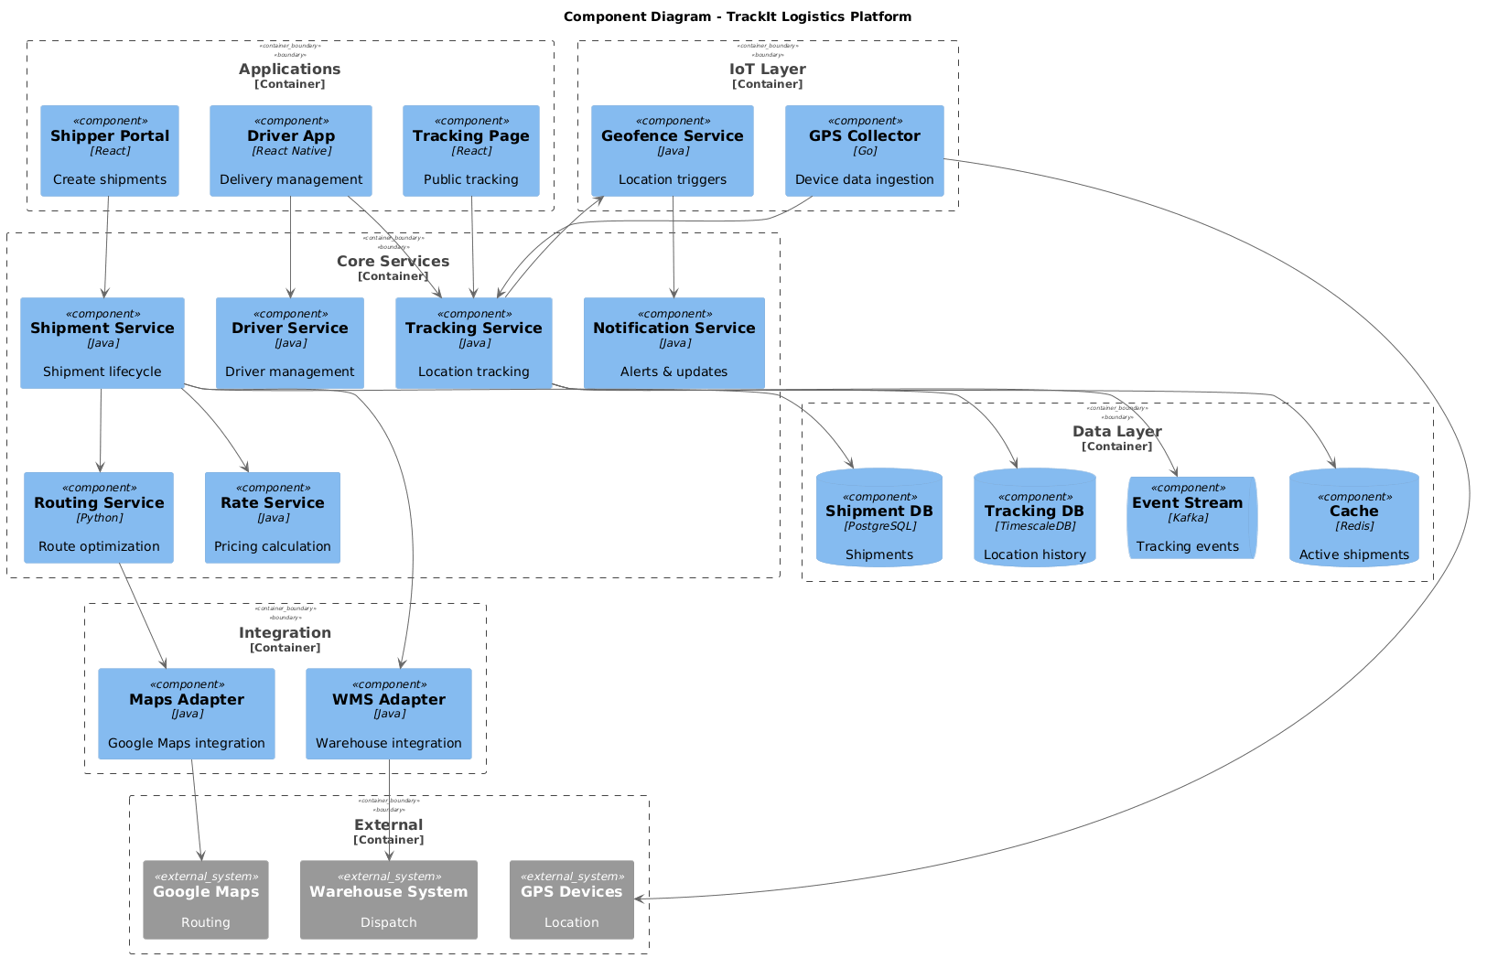

3.2. Non-Functional Requirements
# | Category | Requirement | Target/SLA
1 | Performance | API Response Time | < 2 seconds for 95th percentile
2 | Performance | Transaction Throughput | Support 100 TPS during peak hours
3 | Availability | System Uptime | 99.9% availability (excluding planned maintenance)
4 | Availability | Recovery Time Objective (RTO) | < 4 hours
5 | Availability | Recovery Point Objective (RPO) | < 1 hour
6 | Scalability | Horizontal Scaling | Support auto-scaling based on load
7 | Scalability | Concurrent Users | Support 1000 concurrent users
8 | Data Retention | Transaction Logs | Retain for 7 years as per regulatory requirements
9 | Data Retention | Audit Logs | Retain for 5 years
10 | Compliance | Regulatory | Comply with CMA and SAMA regulations
11 | Compliance | Data Protection | Comply with data privacy requirements

3.3. Security Considerations
# | Security Domain | Requirement | Implementation
1 | Authentication | User Authentication | OAuth 2.0 / JWT tokens with secure token storage
2 | Authentication | Service-to-Service Auth | Mutual TLS (mTLS) for internal service communication
3 | Authentication | Multi-Factor Authentication | MFA required for sensitive operations
4 | Authorization | Role-Based Access Control | RBAC implemented with principle of least privilege
5 | Authorization | API Authorization | Scope-based access control for API endpoints
6 | Data Protection | Data in Transit | TLS 1.2+ encryption for all network communication
7 | Data Protection | Data at Rest | AES-256 encryption for sensitive data storage
8 | Data Protection | PII/Sensitive Data | Data masking and tokenization for sensitive fields
9 | API Security | Input Validation | Server-side validation of all input parameters
10 | API Security | Rate Limiting | Rate limiting to prevent abuse and DDoS attacks
11 | API Security | CORS Policy | Strict CORS policy for web API endpoints
12 | Audit & Logging | Audit Trail | Log all security-relevant events with timestamps
13 | Audit & Logging | Log Protection | Immutable logs with tamper detection
14 | Vulnerability Management | Security Scanning | Regular SAST/DAST scanning in CI/CD pipeline
15 | Vulnerability Management | Dependency Scanning | Automated scanning for vulnerable dependencies

4. Shipment Creation and Dispatch

4.1. Sequence Diagram
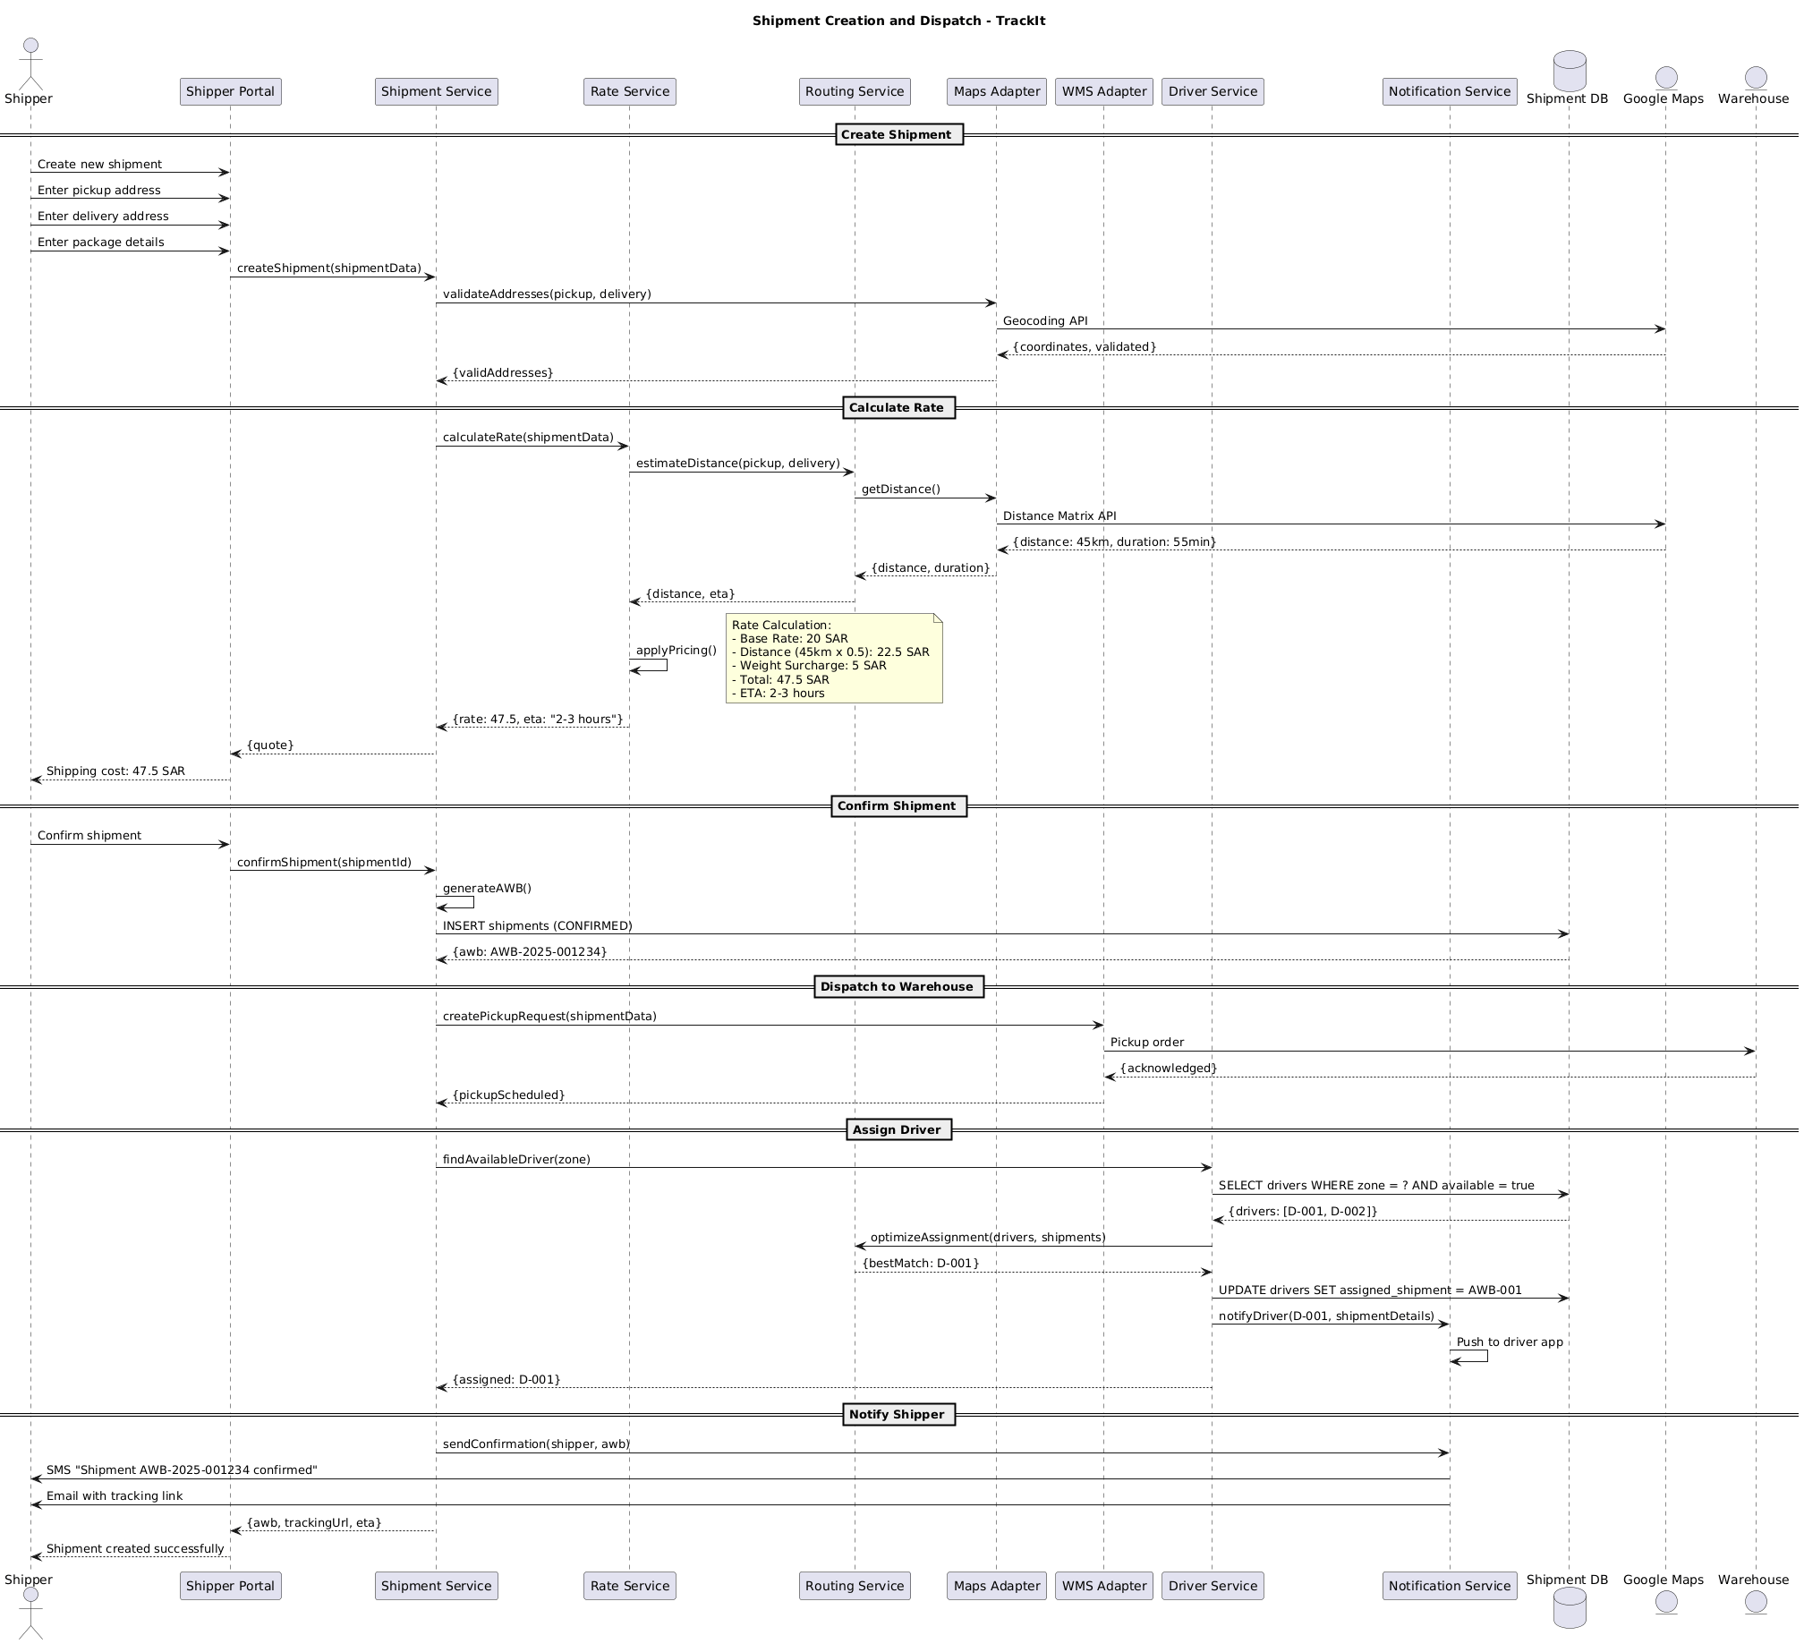

4.2. Flow Description
  - Overview
This flow describes the end-to-end process for shipment creation and dispatch in the TrackIt platform. The process involves the following actively participating actors and systems: Shipper, Shipper Portal, Shipment Service, Rate Service, Routing Service, Maps Adapter, WMS Adapter, Driver Service, Notification Service, Shipment DB, Google Maps, and Warehouse. Each participant is responsible for specific interactions, validations, computations, and notifications required to create, rate, confirm, dispatch, and assign a shipment, as well as to notify all relevant parties.
  - Process Flow
Create Shipment
The process begins when Shipper initiates the creation of a new shipment through Shipper Portal. Shipper provides the pickup address, delivery address, and package details to Shipper Portal. Shipper Portal then sends a request to Shipment Service to create the shipment using the provided shipment data.
Shipment Service forwards the addresses to Maps Adapter to validate both the pickup and delivery locations. Maps Adapter interacts with Google Maps using the Geocoding API to obtain coordinates and validate the addresses. Google Maps returns the validated coordinates, which Maps Adapter relays back to Shipment Service.
Calculate Rate
Once addresses are validated, Shipment Service requests a rate calculation from Rate Service using the shipment data. Rate Service asks Routing Service to estimate the distance between the pickup and delivery locations. Routing Service calls Maps Adapter to obtain the distance, which in turn queries Google Maps via the Distance Matrix API. Google Maps responds with the calculated distance and estimated duration. Maps Adapter provides this information to Routing Service, which then returns the distance and estimated time of arrival to Rate Service.
Rate Service internally performs an operation to apply pricing.
Note: Rate Calculation:
- Base Rate: 20 SAR
- Distance (45km x 0.5): 22.5 SAR
- Weight Surcharge: 5 SAR
- Total: 47.5 SAR
- ETA: 2-3 hours
After applying the pricing logic, Rate Service sends the calculated rate and ETA to Shipment Service. Shipment Service provides the rate quote to Shipper Portal, which then displays the shipping cost to Shipper.
Confirm Shipment
If Shipper decides to proceed, Shipper confirms the shipment through Shipper Portal. Shipper Portal submits a confirmation request to Shipment Service with the shipment ID.
Shipment Service internally performs an operation to generate the Air Waybill number. Shipment Service then inserts the confirmed shipment record into Shipment DB. Shipment DB returns the generated AWB to Shipment Service.
Dispatch to Warehouse
Shipment Service requests WMS Adapter to create a pickup request for the shipment. WMS Adapter sends a pickup order to Warehouse. Warehouse acknowledges the pickup order, and WMS Adapter confirms the pickup scheduling to Shipment Service.
Assign Driver
Shipment Service asks Driver Service to find an available driver for the shipment's zone. Driver Service queries Shipment DB to select drivers who are available in the specified zone. Shipment DB returns a list of available drivers to Driver Service.
Driver Service requests Routing Service to optimize the assignment of drivers to shipments. Routing Service responds with the best driver match. Driver Service updates Shipment DB to assign the selected driver to the shipment. Driver Service then notifies Notification Service to inform the assigned driver with the shipment details.
Notification Service internally performs an operation to push the notification to the driver app.
Driver Service confirms the driver assignment to Shipment Service.
Notify Shipper
Shipment Service instructs Notification Service to send a shipment confirmation to Shipper with the AWB. Notification Service sends an SMS to Shipper confirming the shipment and also sends an email with the tracking link.
Finally, Shipment Service provides Shipper Portal with the AWB, tracking URL, and ETA. Shipper Portal notifies Shipper that the shipment has been created successfully.

4.3. State Machine Diagram
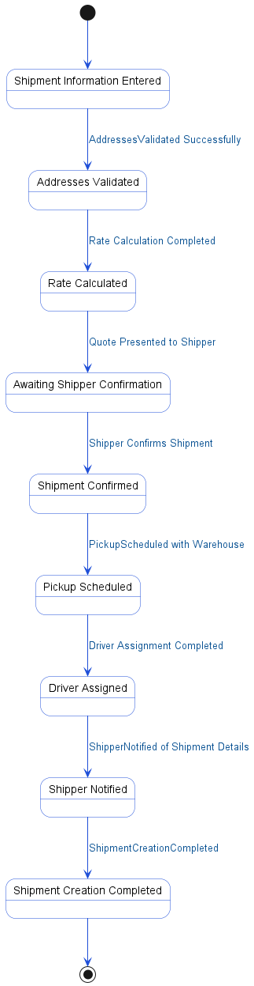

4.4. APIs Contract Agreement
# | Source | Destination | API | Protocol | Request Parameters | Response Parameters
1 | Shipper Portal | Shipment Service | createShipment | REST | shipmentData | {quote}
2 | Shipment Service | Maps Adapter | validateAddresses | REST | pickup, delivery | {validAddresses}
3 | Maps Adapter | Google Maps | Geocoding API | REST |  | {coordinates, validated}
4 | Shipment Service | Rate Service | calculateRate | REST | shipmentData | {rate: 47.5, eta: "2-3 hours"}
5 | Rate Service | Routing Service | estimateDistance | REST | pickup, delivery | {distance, eta}
6 | Routing Service | Maps Adapter | getDistance | REST |  | {distance, duration}
7 | Maps Adapter | Google Maps | Distance Matrix API | REST |  | {distance: 45km, duration: 55min}
8 | Shipper Portal | Shipment Service | confirmShipment | REST | shipmentId | {awb, trackingUrl, eta}
9 | Shipment Service | Shipment DB | INSERT shipments | JDBC | CONFIRMED | {awb: AWB-2025-001234}
10 | Shipment Service | WMS Adapter | createPickupRequest | REST | shipmentData | {pickupScheduled}
11 | WMS Adapter | Warehouse | Pickup order | REST |  | {acknowledged}
12 | Shipment Service | Driver Service | findAvailableDriver | REST | zone | {assigned: D-001}
13 | Driver Service | Shipment DB | SELECT drivers WHERE zone = ? AND available = true | JDBC |  | {drivers: [D-001, D-002]}
14 | Driver Service | Routing Service | optimizeAssignment | REST | drivers, shipments | {bestMatch: D-001}
15 | Driver Service | Shipment DB | UPDATE drivers SET assigned_shipment = AWB-001 | JDBC
16 | Driver Service | Notification Service | notifyDriver | REST | D-001, shipmentDetails
17 | Shipment Service | Notification Service | sendConfirmation | REST | shipper, awb
18 | Notification Service | Shipper | SMS "Shipment AWB-2025-001234 confirmed" | REST
19 | Notification Service | Shipper | Email with tracking link | REST
[*] Indicates that the data element is optional

4.5. Error Handling
# | Source | Destination | Scenario | Handling
1 | Shipment Service | Maps Adapter | validateAddresses  Maps Adapter times out while validating addresses | Retry up to 3 times with exponential backoff; Log error with correlation ID for traceability; Return error code to upstream caller
2 | Shipment Service | Maps Adapter | validateAddresses  Maps Adapter unavailable during address validation | Retry up to 3 times with exponential backoff; Activate circuit breaker, use fallback response; Log error with correlation ID for traceability; Notify operations team via alert if repeated
3 | Maps Adapter | Google Maps | Geocoding API  Google Maps returns no results for provided addresses | Log error with correlation ID for traceability; Return error code to upstream caller
4 | Shipment Service | Rate Service | calculateRate  Rate Service times out during rate calculation | Retry up to 3 times with exponential backoff; Log error with correlation ID for traceability; Return error code to upstream caller
5 | Shipment Service | Rate Service | calculateRate  Rate Service unavailable during rate calculation | Retry up to 3 times with exponential backoff; Activate circuit breaker, use fallback response; Log error with correlation ID for traceability; Notify operations team via alert if repeated
6 | Rate Service | Routing Service | estimateDistance  Routing Service times out during distance estimation | Retry up to 3 times with exponential backoff; Log error with correlation ID for traceability; Return error code to upstream caller
7 | Rate Service | Routing Service | estimateDistance  Routing Service unavailable during distance estimation | Retry up to 3 times with exponential backoff; Activate circuit breaker, use fallback response; Log error with correlation ID for traceability; Notify operations team via alert if repeated
8 | Routing Service | Maps Adapter | getDistance  Maps Adapter times out during distance calculation | Retry up to 3 times with exponential backoff; Log error with correlation ID for traceability; Return error code to upstream caller
9 | Routing Service | Maps Adapter | getDistance  Maps Adapter unavailable during distance calculation | Retry up to 3 times with exponential backoff; Activate circuit breaker, use fallback response; Log error with correlation ID for traceability; Notify operations team via alert if repeated
10 | Maps Adapter | Google Maps | Distance Matrix API  Google Maps returns no distance data for route | Log error with correlation ID for traceability; Return error code to upstream caller
11 | Shipment Service | WMS Adapter | createPickupRequest  WMS Adapter times out during pickup request creation | Ensure idempotency to avoid duplicates on retry; Retry up to 3 times with exponential backoff; Log error with correlation ID for traceability; Return error code to upstream caller
12 | Shipment Service | WMS Adapter | createPickupRequest  WMS Adapter unavailable during pickup request creation | Ensure idempotency to avoid duplicates on retry; Retry up to 3 times with exponential backoff; Activate circuit breaker, use fallback response; Log error with correlation ID for traceability; Notify operations team via alert if repeated
13 | Shipment Service | WMS Adapter | createPickupRequest  Duplicate pickup request received by WMS Adapter | Ensure idempotency to avoid duplicates on retry; Log error with correlation ID for traceability; Return error code to upstream caller
14 | Driver Service | Routing Service | optimizeAssignment  Routing Service times out during driver assignment optimization | Retry up to 3 times with exponential backoff; Log error with correlation ID for traceability; Return error code to upstream caller
15 | Driver Service | Routing Service | optimizeAssignment  Routing Service unavailable during driver assignment optimization | Retry up to 3 times with exponential backoff; Activate circuit breaker, use fallback response; Log error with correlation ID for traceability; Notify operations team via alert if repeated
16 | Driver Service | Notification Service | notifyDriver  Notification Service times out when notifying driver | Retry up to 3 times with exponential backoff; Log error with correlation ID for traceability; Queue request for asynchronous retry
17 | Driver Service | Notification Service | notifyDriver  Notification Service unavailable when notifying driver | Retry up to 3 times with exponential backoff; Activate circuit breaker, use fallback response; Log error with correlation ID for traceability; Notify operations team via alert if repeated
18 | Shipment Service | Notification Service | sendConfirmation  Notification Service times out when sending confirmation to shipper | Retry up to 3 times with exponential backoff; Log error with correlation ID for traceability; Queue request for asynchronous retry
19 | Shipment Service | Notification Service | sendConfirmation  Notification Service unavailable when sending confirmation to shipper | Retry up to 3 times with exponential backoff; Activate circuit breaker, use fallback response; Log error with correlation ID for traceability; Notify operations team via alert if repeated

5. Real-Time Delivery Tracking

5.1. Sequence Diagram
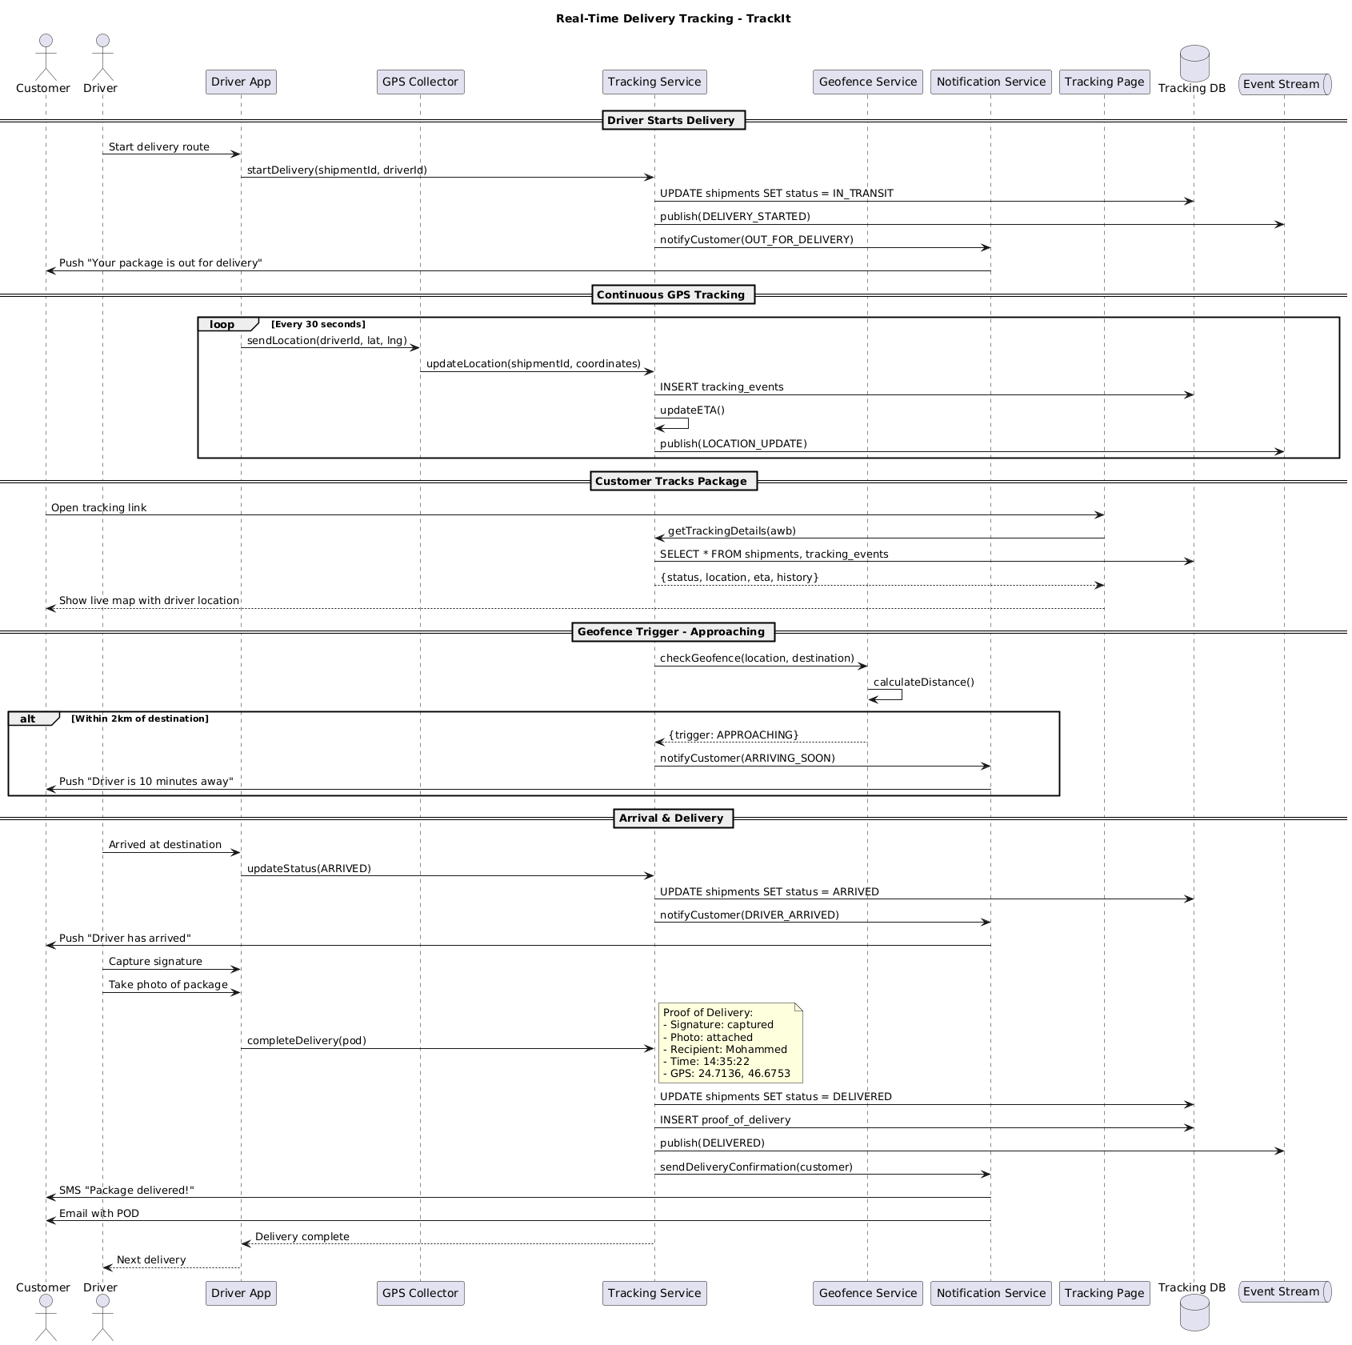

5.2. Flow Description
  - Overview
This flow describes the real-time delivery tracking process for the TrackIt system, detailing the interactions between Customer, Driver, Driver App, GPS Collector, Tracking Service, Geofence Service, Notification Service, Tracking Page, Tracking DB, and Event Stream. The flow covers the initiation of a delivery route, continuous GPS-based location updates, customer tracking interactions, geofence-based notifications, and the final proof of delivery process. Each system and actor is responsible for specific steps in the tracking and notification lifecycle, ensuring timely updates and transparency for both the customer and operational teams.
  - Process Flow
Driver Starts Delivery
The process begins when Driver initiates the delivery route through Driver App. Driver App sends a request to Tracking Service to start the delivery, providing the shipment and driver identifiers. Tracking Service updates the shipment status to 'IN_TRANSIT' in Tracking DB. It then publishes a 'DELIVERY_STARTED' event to Event Stream. Tracking Service notifies Notification Service to inform the customer that their package is out for delivery. Notification Service pushes a notification to Customer stating, "Your package is out for delivery."
Continuous GPS Tracking
Every 30 seconds, Driver App sends the current driver location (latitude and longitude) to GPS Collector. GPS Collector forwards the updated location, along with the shipment identifier, to Tracking Service. Tracking Service inserts a new tracking event into Tracking DB. Tracking Service internally performs an updateETA() operation. Tracking Service publishes a 'LOCATION_UPDATE' event to Event Stream. This cycle repeats at the specified interval for the duration of the delivery.
Customer Tracks Package
When Customer opens the tracking link, Tracking Page receives the request and queries Tracking Service for tracking details using the airway bill number. Tracking Service retrieves the relevant shipment and tracking event data from Tracking DB. Tracking Service returns the status, location, estimated time of arrival, and tracking history to Tracking Page. Tracking Page presents a live map and the driver's current location to Customer.
Geofence Trigger - Approaching
Tracking Service checks the proximity of the delivery by sending the current location and destination to Geofence Service. Geofence Service internally performs a calculateDistance() operation. If the driver is within 2km of the destination, Geofence Service returns a trigger indicating 'APPROACHING' to Tracking Service. Tracking Service notifies Notification Service to alert the customer that the driver is arriving soon. Notification Service pushes a notification to Customer stating, "Driver is 10 minutes away."
Arrival & Delivery
Upon arrival at the destination, Driver notifies Driver App. Driver App sends an update to Tracking Service to mark the status as 'ARRIVED'. Tracking Service updates the shipment status to 'ARRIVED' in Tracking DB. Tracking Service instructs Notification Service to inform the customer that the driver has arrived. Notification Service pushes a notification to Customer stating, "Driver has arrived."
Driver then uses Driver App to capture the recipient's signature and take a photo of the package. Driver App sends the proof of delivery to Tracking Service for completion of the delivery.
Note: Proof of Delivery:
- Signature: captured
- Photo: attached
- Recipient: Mohammed
- Time: 14:35:22
- GPS: 24.7136, 46.6753
Tracking Service updates the shipment status to 'DELIVERED' in Tracking DB. Tracking Service inserts the proof of delivery record into Tracking DB. Tracking Service publishes a 'DELIVERED' event to Event Stream. Tracking Service instructs Notification Service to send a delivery confirmation to the customer. Notification Service sends an SMS to Customer stating, "Package delivered!" and also emails the proof of delivery. Tracking Service notifies Driver App that the delivery is complete. Driver App informs Driver to proceed to the next delivery.
  - Self-Interactions
Tracking Service internally performs an updateETA() operation.
Geofence Service internally performs a calculateDistance() operation.

5.3. State Machine Diagram
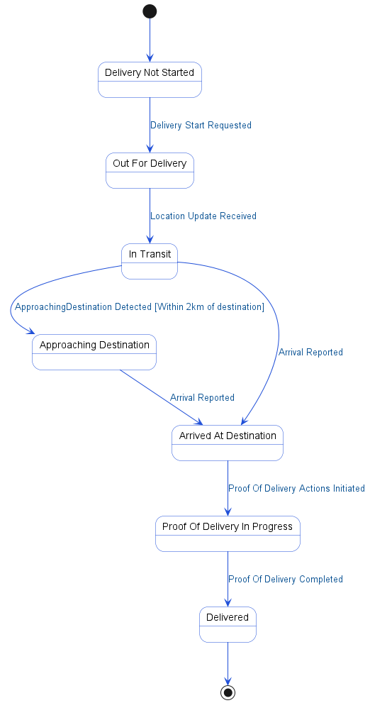

5.4. APIs Contract Agreement
# | Source | Destination | API | Protocol | Request Parameters | Response Parameters
1 | Driver App | Tracking Service | startDelivery | REST | shipmentId, driverId | Delivery complete
2 | Tracking Service | Tracking DB | UPDATE shipments SET status = IN_TRANSIT | JDBC
3 | Tracking Service | Event Stream | publish | REST | DELIVERY_STARTED
4 | Tracking Service | Notification Service | notifyCustomer | REST | OUT_FOR_DELIVERY
5 | Notification Service | Customer | Push "Your package is out for delivery" | REST
6 | Driver App | GPS Collector | sendLocation | REST | driverId, lat, lng
7 | GPS Collector | Tracking Service | updateLocation | REST | shipmentId, coordinates
8 | Tracking Service | Tracking DB | INSERT tracking_events | JDBC
9 | Tracking Service | Event Stream | publish | REST | LOCATION_UPDATE
10 | Tracking Page | Tracking Service | getTrackingDetails | REST | awb | {status, location, eta, history}
11 | Tracking Service | Tracking DB | SELECT * FROM shipments, tracking_events | JDBC
12 | Tracking Service | Geofence Service | checkGeofence | REST | location, destination | {trigger: APPROACHING}
13 | Tracking Service | Notification Service | notifyCustomer | REST | ARRIVING_SOON
14 | Notification Service | Customer | Push "Driver is 10 minutes away" | REST
15 | Driver App | Tracking Service | updateStatus | REST | ARRIVED
16 | Tracking Service | Tracking DB | UPDATE shipments SET status = ARRIVED | JDBC
17 | Tracking Service | Notification Service | notifyCustomer | REST | DRIVER_ARRIVED
18 | Notification Service | Customer | Push "Driver has arrived" | REST
19 | Driver App | Tracking Service | completeDelivery | REST | pod
20 | Tracking Service | Tracking DB | UPDATE shipments SET status = DELIVERED | JDBC
21 | Tracking Service | Tracking DB | INSERT proof_of_delivery | JDBC
22 | Tracking Service | Event Stream | publish | REST | DELIVERED
23 | Tracking Service | Notification Service | sendDeliveryConfirmation | REST | customer
24 | Notification Service | Customer | SMS "Package delivered!" | REST
25 | Notification Service | Customer | Email with POD | REST
[*] Indicates that the data element is optional

5.5. Error Handling
# | Source | Destination | Scenario | Handling
1 | Driver App | GPS Collector | sendLocation  GPS Collector times out before responding | Retry up to 3 times with exponential backoff; Log error with correlation ID for traceability; Notify operations team via alert if repeated
2 | Driver App | GPS Collector | sendLocation  GPS Collector service unavailable | Retry up to 3 times with exponential backoff; Log error with correlation ID for traceability; Notify operations team via alert if repeated
3 | GPS Collector | Tracking Service | updateLocation  Tracking Service times out before responding | Retry up to 3 times with exponential backoff; Log error with correlation ID for traceability; Notify operations team via alert if repeated
4 | GPS Collector | Tracking Service | updateLocation  Tracking Service service unavailable | Retry up to 3 times with exponential backoff; Log error with correlation ID for traceability; Notify operations team via alert if repeated
5 | Tracking Service | Geofence Service | checkGeofence  Geofence Service times out before responding | Retry up to 3 times with exponential backoff; Log error with correlation ID for traceability; Activate circuit breaker, use fallback response
6 | Tracking Service | Geofence Service | checkGeofence  Geofence Service service unavailable | Retry up to 3 times with exponential backoff; Log error with correlation ID for traceability; Activate circuit breaker, use fallback response
7 | Tracking Service | Notification Service | notifyCustomer  Notification Service times out before responding | Retry up to 3 times with exponential backoff; Log error with correlation ID for traceability; Queue request for asynchronous retry
8 | Tracking Service | Notification Service | notifyCustomer  Notification Service service unavailable | Retry up to 3 times with exponential backoff; Log error with correlation ID for traceability; Queue request for asynchronous retry
9 | Tracking Service | Notification Service | sendDeliveryConfirmation  Notification Service times out before responding | Retry up to 3 times with exponential backoff; Log error with correlation ID for traceability; Queue request for asynchronous retry
10 | Tracking Service | Notification Service | sendDeliveryConfirmation  Notification Service service unavailable | Retry up to 3 times with exponential backoff; Log error with correlation ID for traceability; Queue request for asynchronous retry
11 | Tracking Page | Tracking Service | getTrackingDetails  Tracking Service times out before responding | Retry up to 3 times with exponential backoff; Log error with correlation ID for traceability; Return error code to upstream caller
12 | Tracking Page | Tracking Service | getTrackingDetails  Tracking Service service unavailable | Retry up to 3 times with exponential backoff; Log error with correlation ID for traceability; Return error code to upstream caller
13 | Tracking Page | Tracking Service | getTrackingDetails  Tracking details not found for given AWB | Log error with correlation ID for traceability; Return error code to upstream caller
14 | Driver App | Tracking Service | startDelivery  Tracking Service times out before responding | Ensure idempotency to avoid duplicates on retry; Retry up to 3 times with exponential backoff; Log error with correlation ID for traceability
15 | Driver App | Tracking Service | startDelivery  Tracking Service service unavailable | Ensure idempotency to avoid duplicates on retry; Retry up to 3 times with exponential backoff; Log error with correlation ID for traceability
16 | Driver App | Tracking Service | startDelivery  Duplicate startDelivery request for same shipmentId | Ensure idempotency to avoid duplicates on retry; Log error with correlation ID for traceability; Return error code to upstream caller
17 | Driver App | Tracking Service | startDelivery  Validation failure due to invalid shipmentId or driverId | Ensure idempotency to avoid duplicates on retry; Log error with correlation ID for traceability; Return error code to upstream caller
18 | Driver App | Tracking Service | updateStatus  Tracking Service times out before responding | Ensure idempotency to avoid duplicates on retry; Retry up to 3 times with exponential backoff; Log error with correlation ID for traceability
19 | Driver App | Tracking Service | updateStatus  Tracking Service service unavailable | Ensure idempotency to avoid duplicates on retry; Retry up to 3 times with exponential backoff; Log error with correlation ID for traceability
20 | Driver App | Tracking Service | updateStatus  Duplicate updateStatus request for same shipmentId | Ensure idempotency to avoid duplicates on retry; Log error with correlation ID for traceability; Return error code to upstream caller
21 | Driver App | Tracking Service | updateStatus  Validation failure due to invalid status or shipmentId | Ensure idempotency to avoid duplicates on retry; Log error with correlation ID for traceability; Return error code to upstream caller
22 | Driver App | Tracking Service | completeDelivery  Tracking Service times out before responding | Ensure idempotency to avoid duplicates on retry; Retry up to 3 times with exponential backoff; Log error with correlation ID for traceability
23 | Driver App | Tracking Service | completeDelivery  Tracking Service service unavailable | Ensure idempotency to avoid duplicates on retry; Retry up to 3 times with exponential backoff; Log error with correlation ID for traceability
24 | Driver App | Tracking Service | completeDelivery  Duplicate completeDelivery request for same shipmentId | Ensure idempotency to avoid duplicates on retry; Log error with correlation ID for traceability; Return error code to upstream caller
25 | Driver App | Tracking Service | completeDelivery  Validation failure due to missing or invalid proof of delivery | Ensure idempotency to avoid duplicates on retry; Log error with correlation ID for traceability; Return error code to upstream caller

6. Appendix

6.1. Shipment Creation and Dispatch Data Elements
# | Service Name | Data Element | Description
1 | createShipment (Request) | shipmentData | Complete shipment details including addresses and package info
2 | validateAddresses (Request) | pickup | Pickup address for shipment collection
3 | validateAddresses (Request) | delivery | Delivery address for shipment destination
4 | validateAddresses (Response) | validAddresses | Validated pickup and delivery addresses
5 | calculateRate (Request) | shipmentData | Complete shipment details for rate calculation
6 | estimateDistance (Request) | pickup | Pickup address for distance estimation
7 | estimateDistance (Request) | delivery | Delivery address for distance estimation
8 | getDistance (Response) | distance | Distance between pickup and delivery locations
9 | getDistance (Response) | duration | Estimated travel duration between locations
10 | estimateDistance (Response) | distance | Distance between pickup and delivery addresses
11 | estimateDistance (Response) | eta | Estimated time of arrival for shipment
12 | calculateRate (Response) | rate | Calculated shipping rate for the shipment
13 | calculateRate (Response) | eta | Estimated delivery time for the shipment
14 | confirmShipment (Request) | shipmentId | Unique identifier for the shipment to confirm
15 | generateAWB (Response) | awb | Air Waybill number assigned to the shipment
16 | createPickupRequest (Request) | shipmentData | Shipment details for warehouse pickup scheduling
17 | createPickupRequest (Response) | pickupScheduled | Confirmation that pickup has been scheduled
18 | findAvailableDriver (Request) | zone | Geographic zone for driver assignment
19 | SELECT drivers WHERE zone = ? AND available = true (Response) | drivers | List of available driver IDs in the specified zone
20 | optimizeAssignment (Request) | drivers | List of available drivers for assignment optimization
21 | optimizeAssignment (Request) | shipments | List of shipments to assign to drivers
22 | optimizeAssignment (Response) | bestMatch | Best matched driver ID for the shipment
23 | notifyDriver (Request) | D-001 | Driver ID to notify for assignment
24 | notifyDriver (Request) | shipmentDetails | Shipment details sent to the assigned driver
25 | notifyDriver (Response) | assigned | Assigned driver ID for the shipment
26 | sendConfirmation (Request) | shipper | Shipper contact information for confirmation notification
27 | sendConfirmation (Request) | awb | Air Waybill number for shipment confirmation
28 | portal (Response) | awb | Air Waybill number for tracking and reference
29 | portal (Response) | trackingUrl | URL for shipment tracking by shipper
30 | portal (Response) | eta | Estimated delivery time for the shipment

6.2. Real-Time Delivery Tracking Data Elements
# | Service Name | Data Element | Description
1 | startDelivery (Request) | shipmentId | Unique identifier for the shipment being delivered
2 | startDelivery (Request) | driverId | Unique identifier for the driver assigned to the delivery
3 | sendLocation (Request) | driverId | Unique identifier for the driver sending location
4 | sendLocation (Request) | lat | Latitude coordinate of the driver's current location
5 | sendLocation (Request) | lng | Longitude coordinate of the driver's current location
6 | updateLocation (Request) | shipmentId | Unique identifier for the shipment whose location is updated
7 | updateLocation (Request) | coordinates | GPS coordinates of the driver's current location
8 | getTrackingDetails (Request) | awb | Air Waybill number or tracking number for the shipment
9 | getTrackingDetails (Response) | status | Current status of the shipment
10 | getTrackingDetails (Response) | location | Latest known location of the shipment
11 | getTrackingDetails (Response) | eta | Estimated time of arrival for the shipment
12 | getTrackingDetails (Response) | history | List of previous tracking events for the shipment
13 | checkGeofence (Request) | location | Current location to check against the geofence
14 | checkGeofence (Request) | destination | Destination location for geofence calculation
15 | checkGeofence (Response) | trigger | Geofence trigger event (e.g., APPROACHING)
16 | updateStatus (Request) | status | New status to update for the shipment
17 | completeDelivery (Request) | pod | Proof of delivery object containing delivery evidence
18 | pod (Request) | Signature | Captured recipient signature as proof of delivery
19 | pod (Request) | Photo | Attached photo of the delivered package
20 | pod (Request) | Recipient | Name of the person who received the package
21 | pod (Request) | Time | Time when delivery was completed
22 | pod (Request) | GPS | GPS coordinates where delivery was completed
23 | sendDeliveryConfirmation (Request) | customer | Customer identifier to send delivery confirmation to

6.3. Solution Architecture Reference Documents
# | Name | File
1 | BRD | Refer to Latest BRD Attached to JIRA Ticket

